***New flower pattern - Sweet sunset***

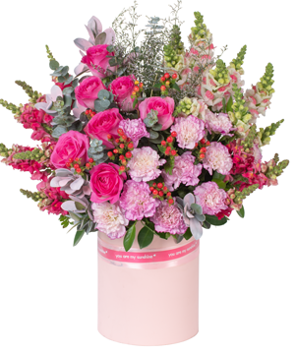

*Is there a more romantic scene than a late afternoon, watching each pink sunbeam at the end of the day shine through the purple clouds that are gently drifting in the distant sky. A combination that cannot be more beautiful between the faithful purple color of carnations and the lovely sweetness of pink candy will be an extremely romantic gift for couples who are immersed in love and happiness.*